**P1 – Describe the technologies required for e-commerce**

**Introduction**

In this report, I will describe the technologies that is required for an e-commerce website.

**Hardware and Software**

**Web server**

A web server processes requests via HTTP. This term can be referred to the whole server, or specifically to a software that accepts and supervises the HTTP requests. HTTP is a protocol that uses logical links to exchange or transfer information between nodes. The web server uses this, and any requests made, the web server gets involved. They are different types of web servers that are run, and some of them are the following: gaming, data storage, hosting websites, and many others. These use the process of requesting via HTTP. For example, gaming server. This uses web server, because they need to communicate online with other gamers. This uses the web server to make any requests to the other user. If one user wants to send a message to the other person, it would use the web server to send the message.

**HTTP**

Hypertext Transfer Protocol (HTTP) is a protocol that is found on the address bar that does two jobs. The first job is that it allows the user to access the information that is on the page and the other is that it transfers hypertext to the server when the process of communication is enabled.

**Browsers**

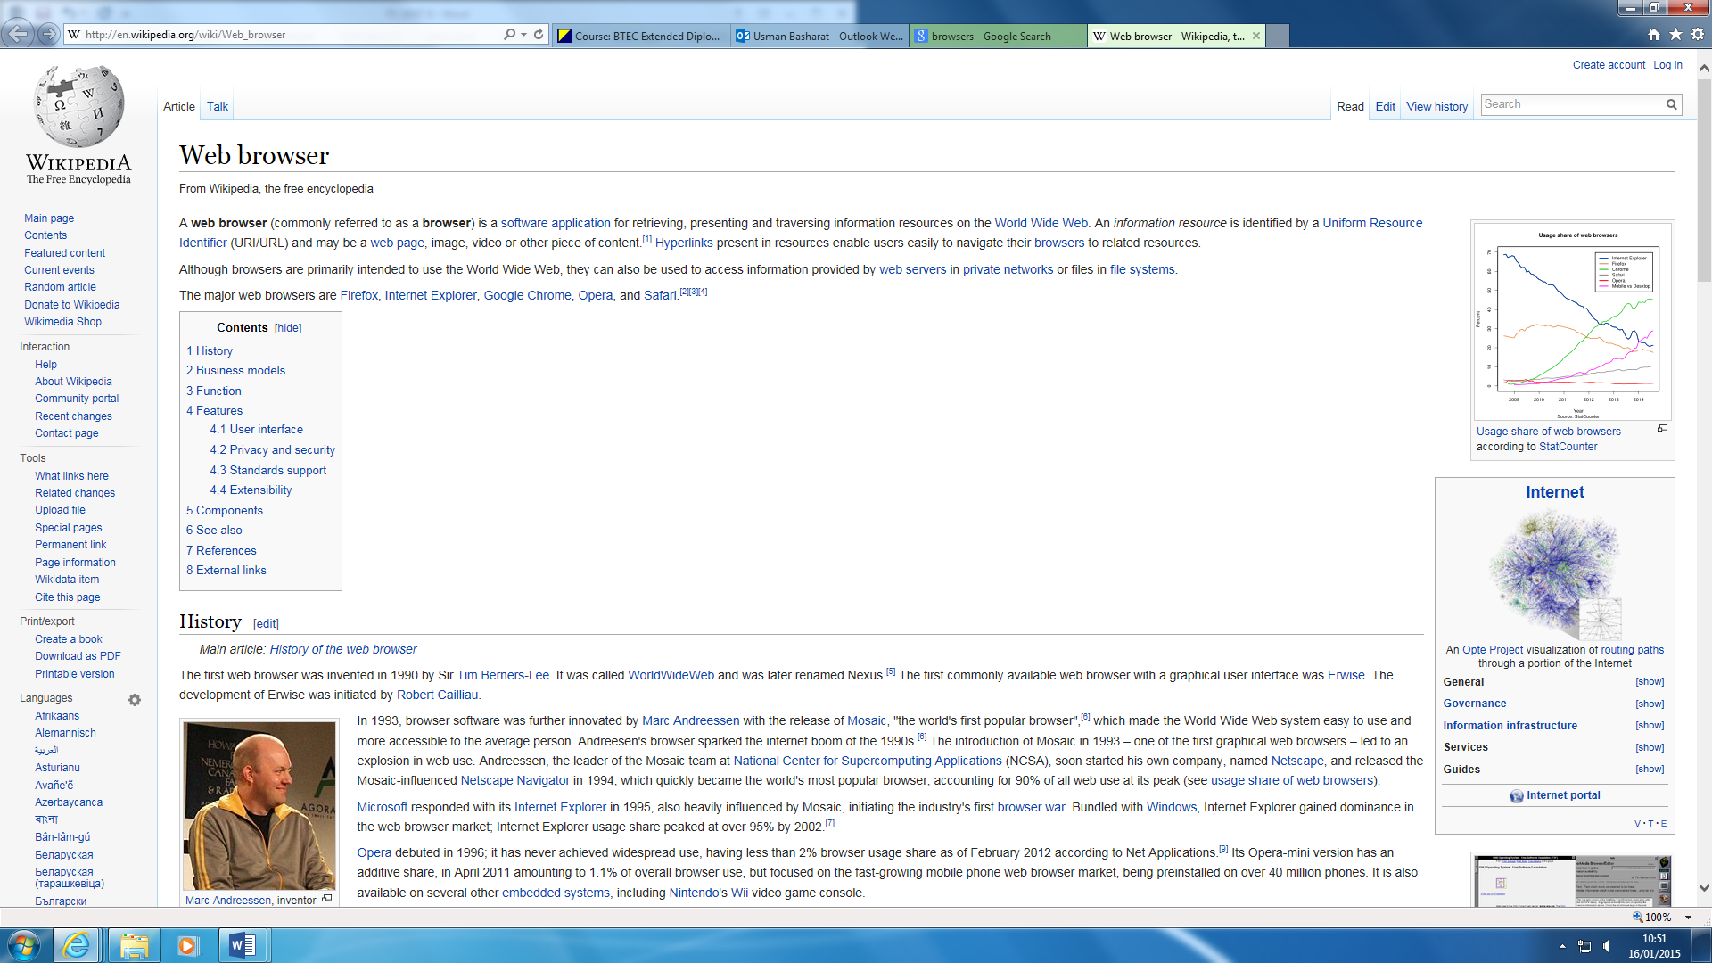A web browser is an application that the user can present, provide information on where anyone in the world that has this application can view. Communication means exchanging of information usually through speaking to another individual, writing a letter to someone or typing messages to another individual on the internet. For example, the picture below shows information that anyone can provide; all you do is type in web browser and it shows you it.

**Cache**

[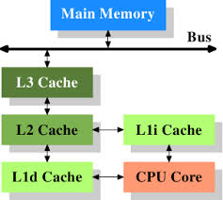](http://www.google.co.uk/url?sa=i&rct=j&q=&esrc=s&source=images&cd=&cad=rja&uact=8&ved=0CAcQjRw&url=http://lwn.net/Articles/252125/&ei=WMpgVNz3O7OKsQSX4oF4&bvm=bv.79189006,d.ZGU&psig=AFQjCNH5aVgkPLaBA5JB3gkkZvBzePOm8A&ust=1415715794084888)A cache is a content that enables the request of the specific site to be located faster. It gets saved, but the computer does not know. This is to improve the input/output of the system. All these saved cache can be cleared, but when the I/O is requested, it will be slow.

Web cache is a temporary storage that stores HTML pages to reduce lag and bandwidth. This can be used within a network, search engine, web browser, and more.

**Server software**

Server could be a computer system that manages, responds or helps other users from a network service. Servers could be run on a computer. The server is the base of communication with the workstation. It enables servers for any type of communication. It could be email server. This enables other workstations (and other servers) to offer a dedicated server to them. The hosting server is the manager of the server. He only can access to all the materials, which other workstations cannot access. Some of the servers you may come across are:

* Chat and discussion servers
* Game clan management servers e.g. Minecraft
* Security servers
* [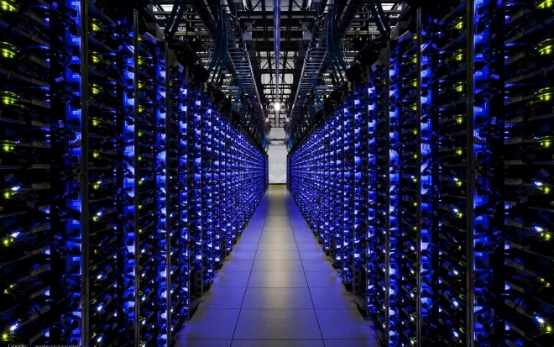](http://www.google.co.uk/url?sa=i&rct=j&q=&esrc=s&frm=1&source=images&cd=&cad=rja&uact=8&docid=Iy-akGclrhlxgM&tbnid=OWcrsrW78v5UkM:&ved=0CAYQjRw&url=http://infiniox.com/cloud-servers-registered-until-2017-for-infiniox-com/&ei=mPomU6sY04OFB7ePgTg&bvm=bv.62922401,d.ZG4&psig=AFQjCNHBCAX2HAj3P_LrNUB3muLal4r48Q&ust=1395149840452732)Web servers

Some of the servers have requirements that you may need to get access to the server. For example, when you want to play Minecraft, you have to be connected with the internet for you to play with others. This is important, as having an internet connection is one of the main requirements. Referring to Figure 1.1, it demonstrates how the Cloud server looks like. It has many cables and devices for it to be connected.

Figure 1.1

**Web authoring tools**

A web authoring tool is a software that is used to create web content. A type of authoring tool could be Adobe Dreamweaver. They provide services that use tools to make websites. Hey are more advance programs that are used on the internet. The picture below shows type of web authoring tool. Any new users can use templates and tutorials of this software to create a website. HTML (hypertext mark-up language) can be used within web authoring tool, i.e. Adobe Dreamweaver can use HTML.

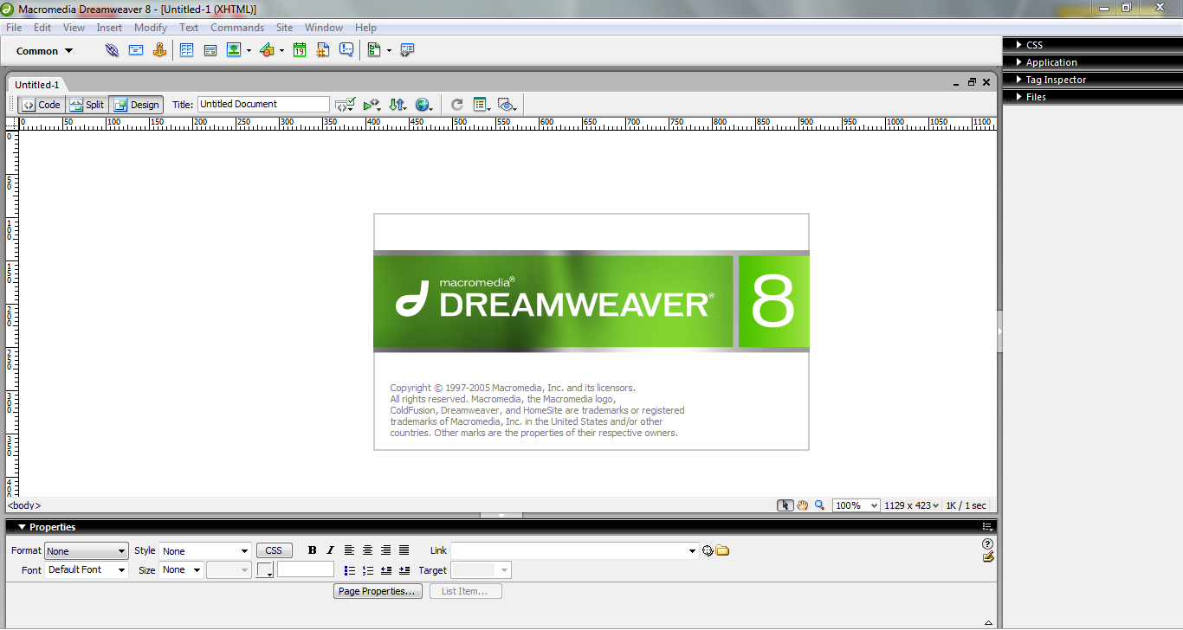

**Database system**

A database system can be used within an e-commerce. This stores information about the product that is used within the website. This could include pricing, images, details, and any other information that can be useful. The company can use the database to check any information that is missing from the website. For example, if amazon has the wrong price on the site, they can go to the database system to double check if it is correct. This is a service that is made by a person and it becomes useful later on.

**Networking**

**TCP/IP addresses**

Application Layer makes the request to the other application you sent it to. HTTP is the common that any person would know. This stands for Hypertext Transfer Protocol. HTTP should take in response to any commands. For example, when you type in the URL the web page, it sends messages to the direct page for it to be done.

Presentation Layer takes care of any issues that occur during the process. It only takes care of any data that is complete only in the application layer. This manages the compression and encryption.

Session Layer manages to open, close and manage a session between the processes. In between the session layer, it has sockets. Sockets have two types, stream sockets and datagram sockets. Stream sockets is a type of internet socket that transmits data on a regular basis. Datagram sockets is a type of connectionless network socket, which is sending or receiving points – relating to session layer.

Transport Layer does all the transportation. TCP stands for Transmission Control Protocol. TCP is reliable, error-checked delivery from one point to another.

Figure 1.3

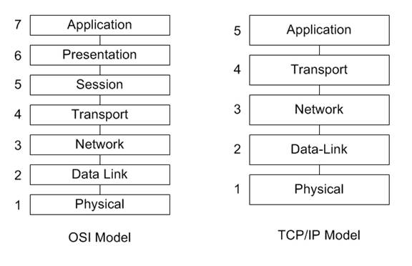Internet Layer or IP layer is method that uses datagram to communicate through another network. It sends short messages. Each computer has its own unique IP address. It uses the IP routers to transmit data.

Network Interface Layer commonly refers to the data link layer. This receives the end package of the communication. This could include IEEE 802.2. The main aim of this layer is to provide trustable communication between the networks. This layer is important as it may cause security issues. One of the ways network interface layer does the data link is through Ethernet. Ethernet is a wire that commonly connects the computer to your router. It can connect Laptops to each other, so the internet connects perfectly.

Physical layer (layer 1) does the raw bits of all the communication throughout the layers. Physical aspects could be through wires, coax cable. Wirelessly communication could be slower as it sends signals, just like Bluetooth, to the other network and sends the data

**Ports and protocols**

Network protocol -It’s within a computer, a communication protocol is a system which plays a part of exchanging messages within or between the computer. The main protocols that are involved in the OSI layer is the following: HTTP, TCP, IP, TCP/IP and Hardware. They are many types of protocols, but these are the main and simple protocols that people should know.

They are many ports on the computer which allows the computer to insert external devices. These ports can be either from the back of the computer or the front. For example, headphones, USBs, and mouse. The image on the right gives you a clear example of a serial port. They are many of them, not only this colour. Most of the time, the ports are located at the back of the computer.

[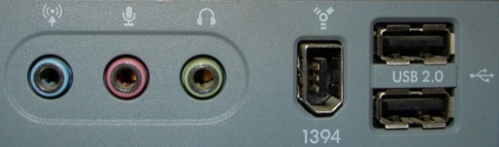](http://www.google.co.uk/url?sa=i&rct=j&q=ports%20computer&source=images&cd=&cad=rja&docid=PYzGBN8vwzrmnM&tbnid=BWoGtW69o7bP1M:&ved=0CAUQjRw&url=http://fantasystock.deviantart.com/art/USB-Sound-Micr-Computer-Ports-50811812&ei=l3Q5UsrVIamN7Qbm-oGgDQ&psig=AFQjCNH8-vxF_eIbBj9emp2fB82zm7Y0Lw&ust=1379583506233005)USB ports allows you to connect external storage, phones. The more advanced the USBs are, the higher the data it can hold. Once inserting the USB, the information stored can be seen straight away. There is no installation of the USB required. The USB port is mainly at the front of the computer.

Serial ports allows you to connect printer, modem, mouse and keyboard. As the image on the right shows that connects to the computer to transmit data. The data transmits through the serial port.

Parallel allows you to connect to the printer. Parallel shares the data through the port. Both of these ports look the same and they are both located at the back of the computer.

**IP Address**

IP stands for Internet Protocol. An IP address is a unique numerical label that is assigned to each device. Each device could not only be a PC, but any device. For example, printer, mobile phone, laptop etc. The job for the IP address is that is used for communication. This can enable communication by finding each other. For example, if I were to send a message to my friend, it would find the location by its IP address and send it to the location.

**Considerations**

**Domain structure**

Domain structure is broken down into levels. Domains are the names that is given at the end of a web-link. For example, [www.google.com](http://www.google.com). The .com is a domain and they are many of these around. These levels are top-level domain (TLD), and third-level domain. Each of these levels are used for different links. TLD is represented as a country code such as .us, .ca, and many more. Third-level domains are used to represent specific products, service or organisation. An example of a third-level domain is .ac.uk. This could be used for a college that is in the United Kingdom.

**Domain name registers**

Domain name registers are people who sell domains. An example of a domain name of where you can register is 123-reg.co.uk. First of all, you need to type in what your name will within the search button. Once this is done, you need to check its availability. This is done by the website showing if it is available. This is important, because any person can register their unique name of the website. Once this is available, the user needs to choose the domain. They can be many, for example, .org, and .biz. Once you have paid for it, you can finalise it and you own it.

**Browser and Platform compatibility**

Browser software is an application that allows users to retrieve, present and traverse information resources on the internet. To find information, it is retrieved on the URL. You type in whatever you want to search, and the information is found. This is why, the internet, is useful. They are different types of browser software, and they are called: Internet Explorer, Mozilla Fox, Google Chrome, and others. These browsers render the web pages you see differently and developers need to consider this when developing web pages.

[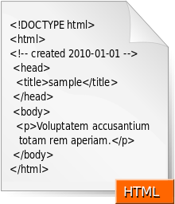](http://en.wikipedia.org/wiki/File:HTML.svg)**Programming requirements**

Programming requirements is important in anything that someone does for e-commerce. Coding is used to explain what is being done. Everything is typed up, and website designers need to keep in mind what to do. HTML (Hypertext Mark-Up Language) coding is one of them. The image shows the code. Referring to the image, this is an example of how coding is done. This also use scripting language e.g. JavaScript.

**Download speed**

Download speed is the performance of the computer. This is based on how many number of bytes per second can be downloaded. The download speed measures how much can be transferred over a certain amount of time. For example, if I were to download something, it says how long it will take it to be complete. If this takes very long to complete, depending on the file, that means the connection is slow. It depends on the connection. If it were very fast, it would take around 2 minutes to complete.

Some examples of where download speed is used is dial-up. Dial-up is way of accessing the internet by using the facilities of a public connection. This is used via telephone lines. Download speed is used within this system. It has a rate, and the maximum is 56KBPS (56,000 bits per second). It is usually described by the customers as slow. Broadband is another example of where it is used, but it is much faster developed. Below shows an example of a download speed used on broadband. They are different types of companies that offer different type of support. Some of them could be BT Broadband, Virgin Media, TalkTalk, and many more.

